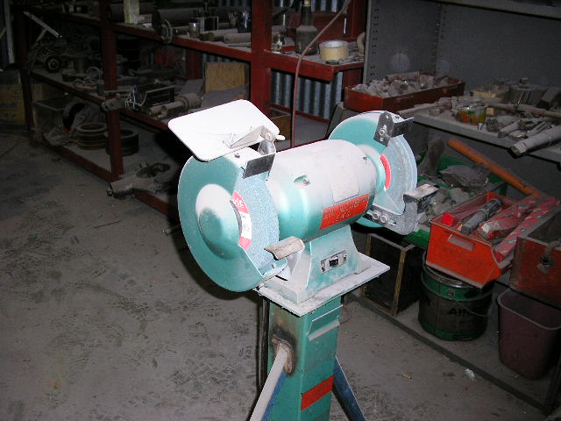 | Hazard Information Sheet
  Equipment: | Grinding
 | Equip Type: | Pedestal Grinder
 | Generic Description or  Specific Make / Model: | Pedestal Grinder
 | Type: | Electric
 | Other Details

Operator Requirements: | Operators must be trained and competent to use this equipment safely. Operators may be restricted by law and need special training.
Purpose For Which This Equip Is Designed: | For smoothing surfaces esp. steel

Hazards & Risks:
Control Measures:
Striking (Hitting):  Stones flying off the wheel | Ensure eye protection worn at all times.
Entanglement (Guarding):  Limbs or clothing coming in contact with blade | Operator to wear proper clothing goggles, steel toed safety boots, hearing protection (breathing mask or respirator, depending on work being done).
Hazardous Substances:  Inhalation of hazardous dust. | Asbestos / other hazardous dust is extremely dangerous to health and specifically approved respirators are required which comply with OH&S regulations.
Noise:  Exposure to noise. | Wear appropriate hearing protection if exposure to noise exceeds 85 dB(A).
Suffocation:  Suffocation due to lack of oxygen, or atmospheric contamination. | (i) Use confined space procedures where applicable.  (ii) If working in poorly ventilated areas monitor fumes at regular intervals.

Disclaimer: In fulfilment of its statutory obligations, (ARS) & John Holland has taken what it considers to be all reasonable precautions and exercised due diligence to ensure that it has provided all relevant information on the safe use of the plant. However, except as required by law and only to the extent so required, (ARS) & John Holland does not make any representation, warranty or undertaking, express or implied, as to, or accept any responsibility or liability for, the accuracy or completeness of, or any errors in or omissions from, this Hazard Information Sheet. Except as required by law and only to the extent so required, neither (ARS) & John Holland nor any of its respective directors, officers, agents, or employees shall in any way be liable directly or indirectly to any person or body for any loss or damages, costs or expenses whatever arising out of or in connection with the information contained in this Hazard Information Sheet. | Date: 19/06/06
Equipment: | Pedestal Grinder  Electric

Hazards & Risks: | Control Measures:
Electrical:  Electric shock or burns due to damaged electrical leads and cables. | Operator to ensure no nicks, cuts or damage to electrical cord and plug before cable use. Use with RCD protected power supply.
Water near electrical equipment. | (i) Do not use in area where tool is likely to get wet.  (ii) When raining ensure tool is sheltered.  (iii) Ensure cord not positioned in or near water, nor likely to get damaged from falling objects, or pedestrian or other traffic.  (iv) When used outdoors, use extension cords designed for outdoor use only.
Coming into contact with hot parts. | Proper guarding of all hot parts where practicable.  Avoid touching hot parts.

Disclaimer: In fulfilment of its statutory obligations, (ARS) & John Holland has taken what it considers to be all reasonable precautions and exercised due diligence to ensure that it has provided all relevant information on the safe use of the plant. However, except as required by law and only to the extent so required, (ARS) & John Holland does not make any representation, warranty or undertaking, express or implied, as to, or accept any responsibility or liability for, the accuracy or completeness of, or any errors in or omissions from, this Hazard Information Sheet. Except as required by law and only to the extent so required, neither (ARS) & John Holland nor any of its respective directors, officers, agents, or employees shall in any way be liable directly or indirectly to any person or body for any loss or damages, costs or expenses whatever arising out of or in connection with the information contained in this Hazard Information Sheet. | Date: 19/06/06

